**Guerrilla marketing: Why Indian Brands Must Use This Strategic Marketing?**

**Introduction** of marketing used in India, which is why 80% of the people reading this article might not know what exactly a Guerilla M

Guerilla marketing is very much a rare kind of marketing is? Well, reading further you will get to know not only the definitions of this strategy but how guerilla marketing can change the image of the company, viewers that don’t even know your brand, well now they will know you for decades, yes you heard it correct just by looking once your audience will remember you for a decade. So, to brief more about the topic let's start by basic definition.

**Table of content**

1. Introduction
2. What is Guerrilla Marketing?
   1. Definition
   2. Explanation
3. Where GM is used?
4. Examples of GM
5. What do the statistics say on the growth of the brand who uses GM?
   1. Why should a brand adopt a Guerrilla Marketing strategy?
   2. Case study of McDonald’s
6. Why Indian brands must use this strategic marketing?

**What is Guerrilla Marketing?**

When we hear the term Guerrilla in Guerrilla Marketing, we feel heavy, strong, conflict, and huge kind of mixed thoughts, and when we hear marketing it seems like something is being promoted, so this is what exactly highlighted in Guerilla Marketing.

**Definition**: Guerrilla Marketing is a strategy of advertisement where a brand promotes its services or products in the most unique, huge, and sarcastic way that one can see and get a WOW feeling. It is unconventional outbound marketing.

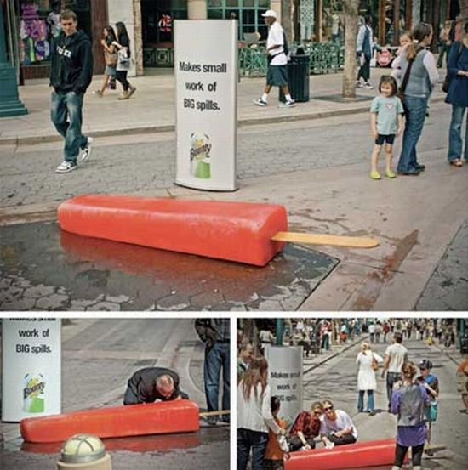**Explanation:** There is no benchmark over here that you must be doing guerrilla marketing in a particular format or a particular place with a set of guidelines that is to be followed, NO, rather guerilla marketing is that creative marketing which is placed at an unusual place, in unusual size and shape, attention seeker and which is too catchy that one looking at it cannot ignore. Also, one individual must feel ambushed, sabotaged, and raid looking at your creativity. For example, see this marketing done by a candy-making company, what do you think this advertisement will fetch how many viewers?

**Where Guerrilla Marketing is used?**

Guerrilla Marketing can be used by any brands, then whether they are providing services, trading, manufacturing products, music company, architecture company, etc. so there is no barrier to using it, it is just a matter of how creative you advertise your brand.

**Some Incredibly Creative examples of Guerrilla Marketing done by Various Brands**

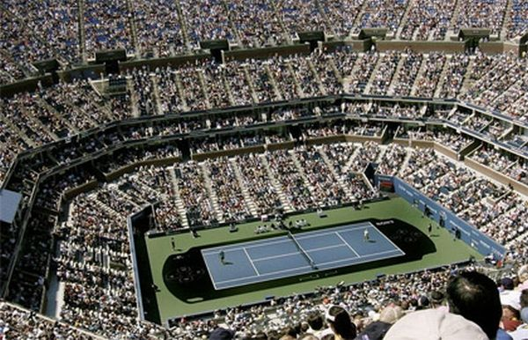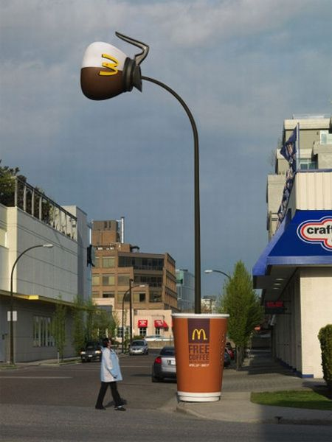

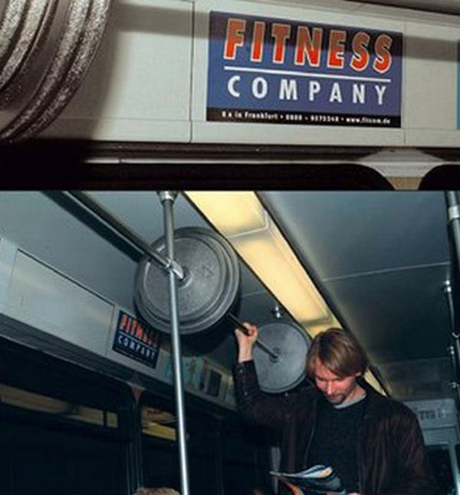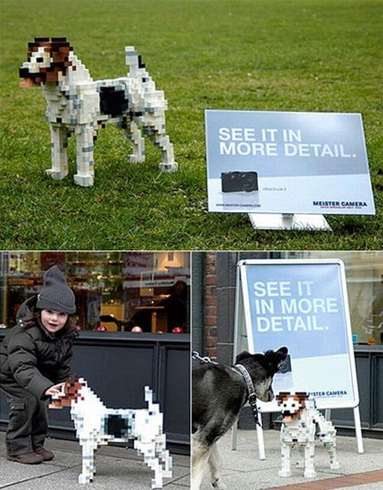

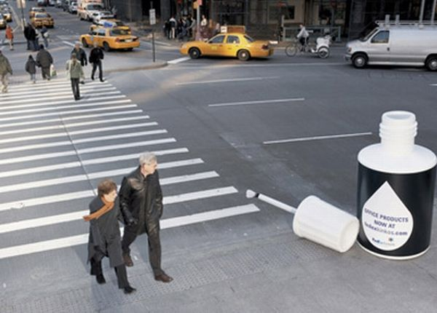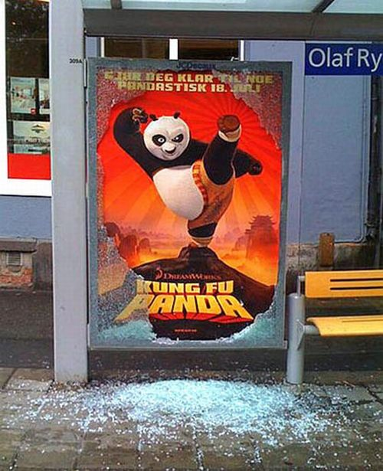

We can see how whether it is a movie, a whitener company, a camera manufacturing company, or a fitness gym, just by using their creative brains they created a lifelong impact on consumer’s minds.

**What does Stats say about the brands that use Guerrilla Marketing Concept?**

Before jumping towards statistics part one question that most of the brands ask why they should adopt these marketing strategies?

The answer is so simple to this, it fetches more customers than any other marketing due to the ambushed feeling that they get while looking at your product at unusual places. It is cost-efficient, more engaging, impression-making and brands can save lots of money resources while efficiently doing guerrilla marketing.

Let’s take a Case study of a brand that does incredibly Creative Guerrilla marketing for so long.

**CASE STUDY**

**Brand: McDonald’s**

**Introduction**: McDonald’s is the world’s largest chain of hamburger fast food restaurants, serving around 68 million customers daily in 119 countries across more than 36000 outlets. The company mainly serves hamburgers, cheeseburger, french-fries, breakfast items, soft drinks, milkshakes, and deserts and the company has expanded its menu to include salads, fish, wraps, smoothies, fruits, and seasoned fries.

**Problem**: MCD was facing its image issues as unhealthy and high calories fast food. Thus, the negative impression on the customers.

**Marketing Campaign used**: Ambient Guerrilla Marketing (due to its unusual placement of ads)

**Traditional campaigns**: It was considered old fashioned and no hike in customers using billboards or any other printed campaign.

**Creative Solution**: They used guerrilla marketing as an upcoming strategy.

The advertisement that they used was ambient and was very engaging than its traditional marketing.

**TRADITIONAL MARKETING CAMPAIGN GUERRILLA MARKETING CAMPAIGN**

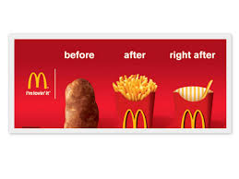

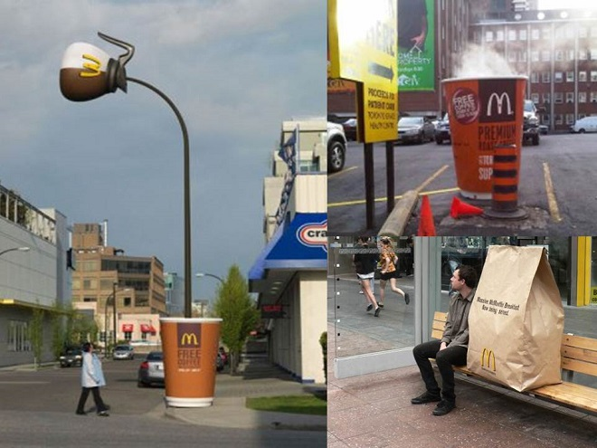

**Result:** After using this strategy a survey was taken and the population was asked about the change in thought process, and the reviews were mixed, some just loved the idea as they got a WOW effect in the brain after watching such promotion, whereas others were having a love-hate review who generally hated or loved the brand name itself, comments such as “ I don’t like coffee at all but after this, I would love to try McD's coffee”, were also found.

**Conclusion:** We can see that company was overall successful in their campaign and they used such kind of advertisement more and more, as this helped them gain the trust of the customers and also helped them improve their negative image, moreover the company’s problem was more health-conscious but Guerrilla marketing helped MCD majorly in surviving faith in their customer.

**Why Indian Brands Must use this Strategy in Marketing?**

We know that marketing in a country like India with its population skewed towards the youth generation is very much important. People trust more on what they see and GM focuses on spreading your word to everyone at a really low cost. Yet many companies with excellent products and services suffer due to the low budget of marketing or else inadequate marketing skills, but nowhere comes Guerrilla marketing which is the only kind of marketing that involves nothing but creative thinking and put your model in a crowded place and Boom! your job is done.

There are many advantages of using GM as a marketing strategy

* It is cost-effective
* It seems more appealing (often gives wow expression)
* Its highly resourceful concept
* Location oriented
* Unconventional (thus don’t require a highly skilled professional which is again cost-effective)
* Successful for almost all brands (small, medium, large enterprises)
* Often called surprise marketing
* You can compete with bigger brands
* Your brand will be remembered Life-long

Currently, there are many Indian startups are facing marketing issues, vocal for local is becoming more popular but less effective, make in India movement has competitors now, there are many marketing problems such as budgeting, lack of proper marketing strategy, not effective social media presence, competition with similar startups that has high funds thus using unconventional methods to reach out to more audience is very attractive and powerful.